Predicting Nightly Price of Airbnb Listings in Toronto, Canada

Milestone Report

George Tang

# Introduction

Airbnb, Inc. is an online marketplace and hospitality service brokerage company. What began as an idea of putting an air mattress in the living room and turning it into to bed-and-breakfast in 2007 “for a few bucks” has grown into an international business with annual revenue of over $2 billion as of 2017. Members (hosts) uses the company’s platform to list their properties to provide accommodation services, in which Airbnb receives commissions from each booking.

One biggest decision that hosts need to make is setting the prices for their listings. Hosts marking their prices too high or too low may risk driving potential customers away or shortchanging themselves. On the other hand, hosts that set prices based on the properties’ locations and features along with competitors’ prices can fully leverage the properties’ true value and maximize their revenues.

While hosts can spend hours searching the Airbnb’s website to get a reference rate, it is time-consuming and often it is difficult to identify properties with features similar to the hosts' in their vicinity. In this project, we will analyze the historical listing information with data analytics, from which factors that affect price will be identified. We will then build machine learning model to predict the listing prices based on input such as host information, properties’ features and booking policy.

## Objective

The objectives of is project are:

* To explore and analyze Airbnb’s listings in Toronto, Canada
* To identify features that affect the prices of a nightly stay
* To develop machine learning models that predict the prices of a nightly stay based on relevant features

In this Milestone Report, we will present a description of the data set (Section 2), the steps for data cleaning and wrangling (Section 3), develop a data story which includes exploratory data analysis (EDA) and statistical analysis (Section 4), and outline the next steps of this project (Chapter 5).

The Python codes used for this report can be found [here](https://github.com/georgecctang/capstone_project_1/blob/master/Capstone%20Project%20%231%20-%20Toronto%20Airbnb%20Data%20Analysis%20(Milestone%20Report).ipynb).

## Significance

Through this project, we will take a deep dive into Toronto's Airbnb listing, and with this effort, we will identify the important features that determine pricing, which the hosts can use as a reference to renovate their properties or booking policy to make them more attractive to customers. We will also develop machine learning models that can be used by the hosts to set fair and competitive prices and ultimately maximize their revenues.

# Dataset

## Airbnb Listings Data

The dataset is obtained from the website [Inside Airbnb](http://www.insideairbnb.com). It is an independent, non-commercial website that allows users to explore how Airbnb is used in cities around the world. The [dataset](http://data.insideairbnb.com/canada/on/toronto/2019-06-04/data/listings.csv.gz) used in this project, referred to as “listings” thereafter, was collected on June 4, 2019.

The listings dataset consists of 20,769 listings (row), and 106 features (columns). Each row consists of a listing in the Greater Toronto area on June 4, 2019.

The features are divided into the following 7 subcategories:

1. Host information
2. Property information
3. Booking information and policy
4. Availability
5. Reviews
6. Airbnb listing information
7. Web scraping information

A list of the features is shown in Appendix I. Most of the feature names are self-explanatory.

## Toronto Geographical Information

Two Wikipedia pages ([here](https://en.wikipedia.org/wiki/List_of_postal_codes_of_Canada:_M) and [here](https://en.wikipedia.org/wiki/List_of_postal_codes_of_Canada:_L)) provides the information that links the listings’ postal codes to their city names. The use of this information will be discussed in Section 3.4.1.

## Mapquest API

As discussed in Section 3.4.1, some listings come with ambiguous geographical information. As such, their geographical information are obtained through [Mapquest’s API](https://business.mapquest.com/products/geocoding-api/) with their latitudes and longitudes as input.

# Data Cleaning and Wrangling

The purpose the data cleaning and wrangling steps are:

1. To ensure the all features are of the correct data type
2. To ensure missing data are properly imputed
3. To create potentially useful features
4. To prepare the dataset for EDA and statistical analysis

## Data Type Correction

The numerical features price, security deposit, cleaning fee, charge for extra people and host response rate are stored as string in the dataset, and as such, their date types are converted to numeric.

The datetime features last scraped, host since, calendar last scraped, first review and last review are stored as string in the dataset, and as such, their data types are converted to datetime.

## Incorrect Price Data Elimination

The feature price is the focus of this study, and as such, its data integrity is of utmost importance.

We find that there are four (4) listings with price of 0, which indicates data issue. Further investigation of the listings’ website indicates that the prices are indeed non-zero; nonetheless, for simplicity, those listings are dropped from the dataset.

## Missing Values Imputation

A list of features with missing values is shown in Appendix II. Overall, 54 of the 106 features consist of missing values, with counts from 1 (0.005%) to 20,769 (100%).

Only features that are considered potentially useful for data analysis will be imputed. For imputation of each feature, a new feature with name [variable]_NA is created to record the listings that originally consist of missing value. It may be useful if the reason for missing is systemic (i.e. non-random).

### Numeric Features

The numeric features host listings count, number of bathrooms, host response rate, bedrooms and beds are imputed with their respective medians.

Missing security deposit and cleaning fee are due the hosts' decision to not include one, which is equivalent to a value of 0. As such, the missing values will be imputed with 0.

For review scores, the missing values are likely due to the facts that either the listings are new with few customers, or their customers did not leave a review score. The missing values are imputed with the feature median values.

### Categorical Features

The categorical feature host response time is imputed with the feature mode.

### Datetime Features

The datetime features host since , first review, and last review are imputed with feature medians.

## New Feature Creation

### City Names

The dataset consists of two features, namely neighbourhood and cleansed neighbourhood, that provide the name of the neighhourhood for each listing. There are 140 unique values for each feature, which may be too granular for data analysis. Instead the city name for each listing may be more appropriate. The information is obtained with the feature zipcode, which is the postal code of the listing. Canada’s postal code consists of six characters, with the first three characters known as the Forward Sortation Area (FSA). The FSA is than matched with the list of cities as discussed Section 2.2.

For listings with erroneous FSA or unknown city names, their city names are obtained with Mapquests API as discussed in Section 2.3, with the listing’s longitude and latitude information as input.

After these steps, there are two listings with missing city information. Additionally, the number of listings for the cities of Thornhill (7), Mississauga (2), Pickering (2), and Markham (1) are exceptionally low. Since all of those are cities of considerable sizes, it is likely that only a small fraction of their listings is included in in this dataset, which make the information non-generalizable. As such, we decided to remove the listings from these cities.

### Indicator Variable for Amenities

The feature “amenities” contains a list of attributes provided by the host that the property contains. It is stored as a string enclosed in curly brackets with each attribute separated by comma. To further evaluate those amenities, a dummy variable is created for each amenity, with '1' and '0' indicating the presence and absence of that amenity, respectively.

A list of amenities along with the percentage of listings with each amenity is shown in Appendix III. In total, there are 196 unique amenities. The rarest amenities are tennis court, brick oven, pool toys and hammock, each only available in 1 listing, while the most common amenities are wifi, heating, essentials, and smoke detector. The amenities should be used with caution nonetheless because the information may not be complete. For instance, hot water should be provided in most properties; yet, only 59% of listings are listed as providing hot water. It is possible that this amenity is so trivial that hosts did not bother to include them.

### Days since Reference Day

The number of days since the recorded events can be a feature more useful than the dates. A reference date of 2019/6/27, which is the date the listings data was scrapped, is chosen.

# Data Storytelling

## Price

As summarized in Table 4‑1, the prices of a nightly stay show considerable variation. While the least expensive listing is $13, the most expensive listing is $13,422. To further investigate, this expensive offer is an “[Art Collector’s House](https://www.airbnb.com/rooms/16039481)” that “will have you living luxuriously just steps from Toronto's most stylish neighbourhood”.

Table 4‑1 Summary of price and log price distribution

|  |  |  |
| --- | --- | --- |
| Mean | 143.35 | 4.66 |
| Standard Deviation | 234.24 | 0.72 |
| Minimum | 13.00 | 2.56 |
| 25% | 64.00 | 4.16 |
| 50% | 101.00 | 4.62 |
| 75% | 160.60 | 5.08 |
| Maximum | 13,422 | 9.50 |

A Q-Q plot of the price, as shown in Figure 4‑1(a), shows that the data is highly right skewed. To reduce the influence of those outliers which are crucial for data visualization and statistical analysis, we apply log transform to the price data, with the Q-Q plot shown in Figure 4‑1(b). While the data is still right-skewed, it is considerably more normally distributed, which is also shown in Figure 4‑2. It is also worth notice that the distribution has a short tail on the left, which means the minimum is higher than what a normal distribution would predict.

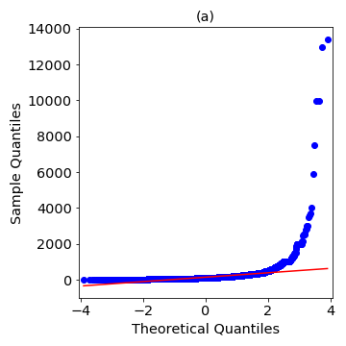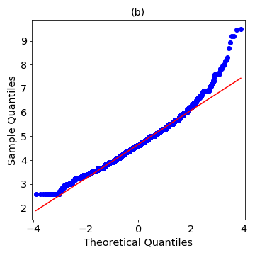

Figure 4‑1 Quantile-quantile plot of (a) price; (b) log price

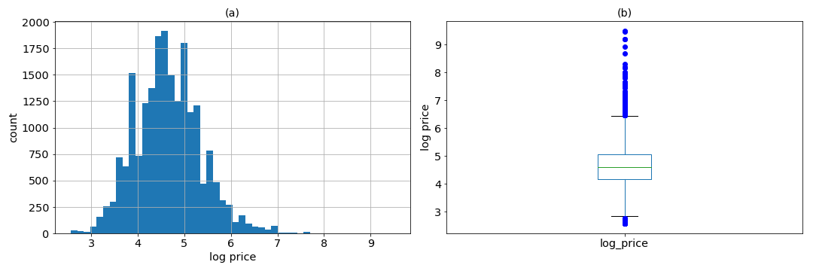

Figure 4‑2 Distribution of log price: (a) histogram, (b) boxplot

## Geographical Information

The count of listings in each region is shown in Figure 4‑3(a). Overall, Toronto (Downtown, Central, East and West) consists of the most combined listings, while among them, Downtown Toronto has the most listing. The York region (York, North York and East York) has the 2nd most combined listings.

The listings price show considerable variable at each region. Downtown Toronto has the highest median price while Scarborough (a suburb northeast of Toronto) has the lowest median price.

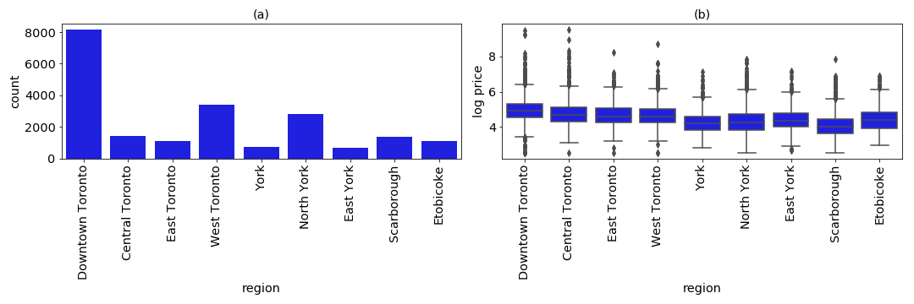

Figure 4‑3 (a) Count of listings and (b) boxplot of log price in each region

## Property Information

### Property Type

The count of listings for each property type is shown in Figure 4‑4.Overall, there are 30 different property types, with 16 of them with counts less than 10. The most common are Apartment, followed by Condominium and House.

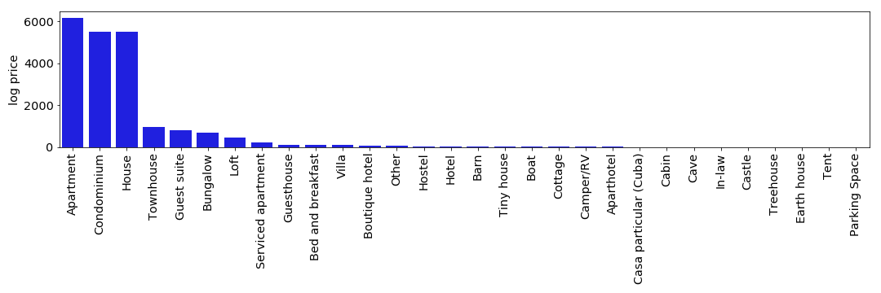

Figure 4‑4 Count of listings for each property type

Bungalow is an interesting property type. According to [Wikipedia](https://en.wikipedia.org/wiki/Bungalow#Canada): “Canada uses the definition of bungalow to mean a single-family dwelling that is one storey high”. In other words, a bungalow is essentially a house. As such, this property type is assigned a value of “House”.

The rest of the property types are assigned a value of “Other” to reduce granularity. Figure 4‑5 shows that condominium has the highest median price while house has the lowest median price.

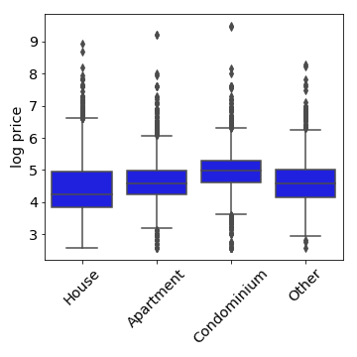

Figure 4‑5 Distribution of log price for each property type

### Room Type

The count of room type for each property type is shown in Figure 4‑6(a). For houses, the most common room type is private room while for both apartment and condominium, the most common room type is entire home/apartment. Shared room is the least common for all property types.

As shown in Figure 4‑6(b), the median price is the highest for the room type of entire home/apartment and lowest for shared room.

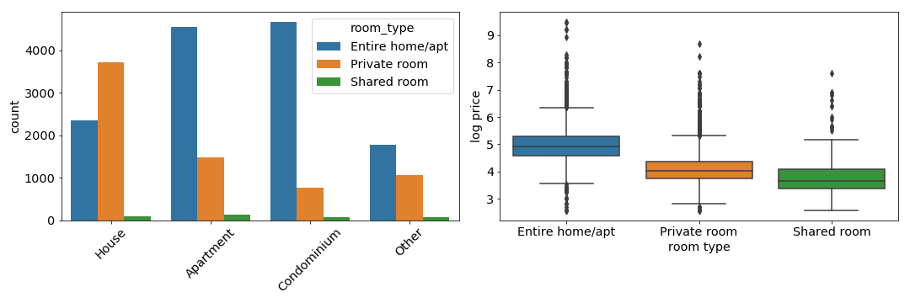

Figure 4‑6 (a) Count of room type and (b) price distribution for each property type

### Property Features

Features that fall into this category include accommodates, bathrooms, bedrooms, and beds, which are all numerical. A heat map of the correlations between the features and log price is shown in Figure 4‑7. All features are somewhat correlated with log price. It is important to notice that the features are correlated with each other which is expected.

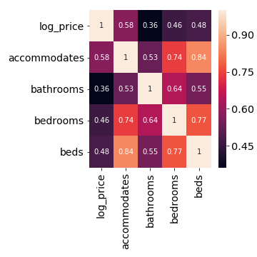

Figure 4‑7 Correlations between property features and log price

### Amenities

With 196 unique amenities, for this analysis, we pick the ones that (1) are intuitively non-trivial and may affect the price, and (2) have a balanced class, with we define as the majority class being less than 90% of the data. The chosen amenities are “bathtub”, “pets allowed”, “pool”, “gym”, “family/kid friendly”, “private entrance”, “free parking on premises”, and “air conditioning”.

As shown in Figure 4‑8, for the eight chosen amenities, the median price is higher for listings with the amenity.

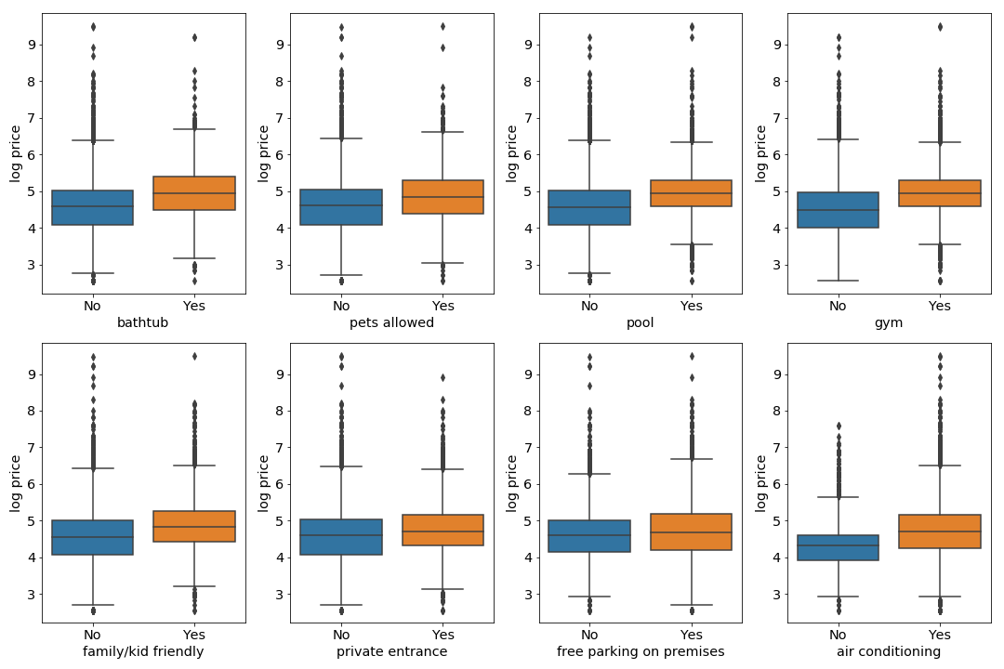

Figure 4‑8 Distribution of log price for listings with and without amenities

## Host Information

### Superhost Status

According to [Airbnb](https://www.airbnb.ca/help/article/828/what-is-a-superhost): “[s]uperhosts are experienced hosts who provide a shining example for other hosts, and extraordinary experiences for their guests”. As such, it is possible that a superhost status would command a higher price due to their good track records and reputations.

As shown in Figure 4‑9(a), about 35% of listings are provided by superhosts. Overall, the median price is slightly higher for listings provided by superhosts (Figure 4‑9(b)); however, the most expensive listings are provided by non-superhosts.

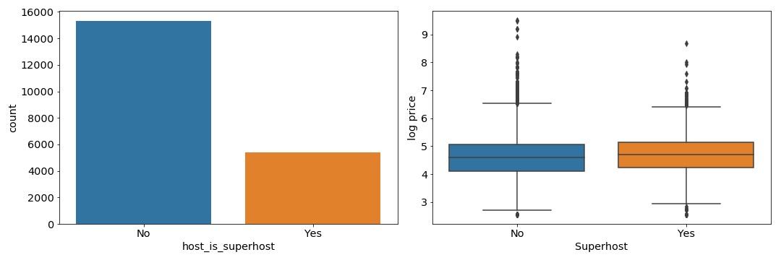

Figure 4‑9 (a) Count of listings and (b) distribution of log price for superhost status

## Booking Policy

### Cleaning Fee

Cleaning fee is a one-time, non-refundable fee charged by the host, regardless of the duration of stay. It is an interesting feature because it can be part of the overall pricing strategy. From customers’ point of view, a lower cleaning fee along with a higher nightly price may encourage shorter term stay, while a higher cleaning fee along with a lower nightly price may encourage longer term stay. Nonetheless, for this project, cleaning fee will be used solely as a predictor for price.

Due to the high skewness of cleaning fee, a log transformation is applied. As shown in Figure 4‑10, there are two distinct populations of cleaning fee. On the left, there is no cleaning fee, either due to 0 or missing value. On the right, there is a positive correlation between log price and log cleaning fee.

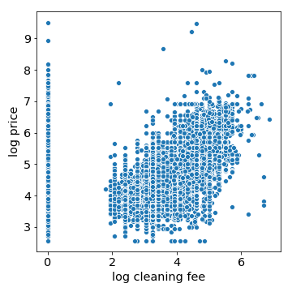

Figure 4‑10 Log price vs log cleaning fee

### Minimum Nights of stay

As shown in Figure 4‑11(a), a majority of listings requires minimum nights of stay of 3 nights or less. There is no obvious difference among them in term of price (Figure 4‑11(b)).

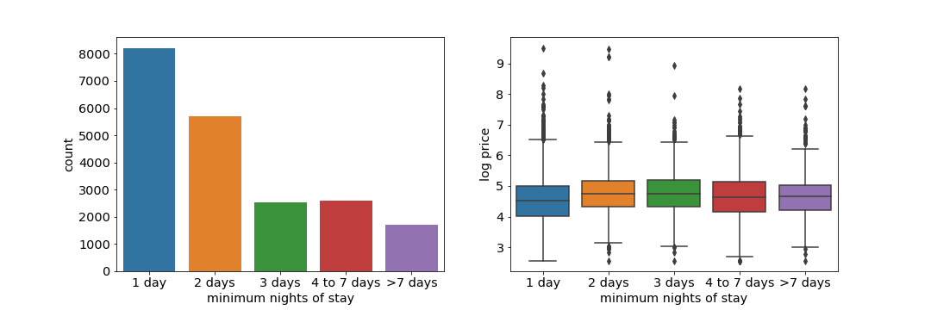

Figure 4‑11 (a) Count of listings and (b) distribution of log price for minimum nights of stay

### Numeric Features

Features that falling into this category include security deposit, cleaning fee, included number of guests, charge for extra people, minimum and maximum nights of stay. Figure 4‑12 shows that security deposit, cleaning fees and included number of guests are correlated with log price.

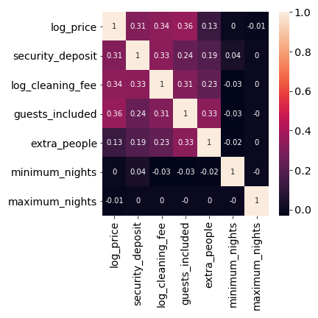

Figure 4‑12 Correlations between booking policy features and log price

## Availability

The dataset provides information on the listings’ availabilities for the next 30, 60, 90 and 365 days. Figure 4‑13 shows that while the availabilities are highly correlated with each other, they are not correlated with log price.

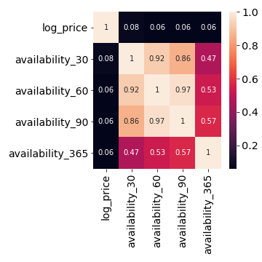

Figure 4‑13 Correlation between availability and log price

## Review Scores

Airbnb allows customers to to provide review scores of their experiences on various categories, including accuracy, cleanliness, check in, communication, and value. Also provided by the data are the number of reviews received by each listing, and the number of reviews of the last twelve months (ltm). Interestingly, Figure 4‑14 shows that the neither the number of reviews nor review scores are correlated with log price.

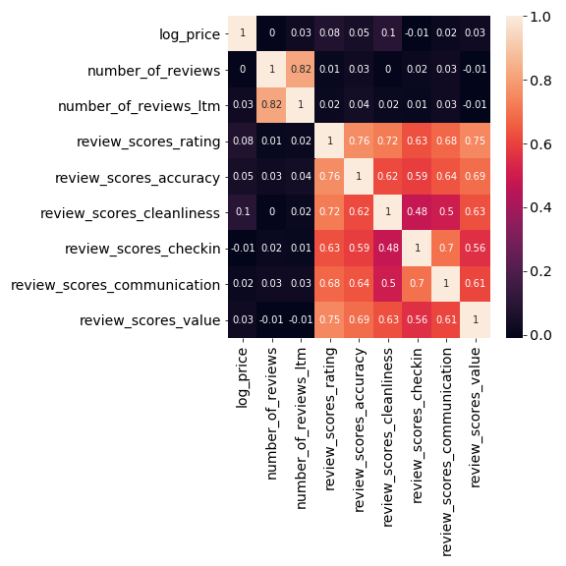

Figure 4‑14 Correlation between review information and log price

4.8 Statistical Analysis of Categorical Features

In this section, we will conduct hypothesis tests on selected categorial features. The null hypothesis is that the distributions of log price are the same among all categories within a feature, where the alternative hypothesis is that the distributions are not the same. Since the log price is not normal, the Mann Whitney U (MWU) test will be used for features with binary response (1/0, or t/f, etc), where Kruskal-Wallis (KW) test will be used for multi-category response. The hypothesis tested by both MWU test and KW test is whether the samples from the different categories are taken from the same population. If they are not, then the feature may be of use to predict the price.

The results of the tests are shown in Appendix IV. For all features, the null hypothesis is rejected, i.e. log price does not have time same distribution among all categories in each feature. It is important to note that, however, with such a large sample size (> 10,000), the null hypothesis will be rejected virtually all the time. As such, this hypothesis testing may not be the most useful. A better approach maybe to use machine learning models to identify features that are useful for predicting nightly price which will be the focus of the next step.

5 Conclusion and Next Steps

In this report, we have detailed the steps of data cleaning and wrangling. We have also explored the data through visualizations and statistical methods.

Features that shows promise in predicting prices include geographical location, property types and room types, number of accommodates, beds, bedrooms, cleaning fee, security deposit, number of guests included, and provision of amenities. It is important to note that features not correlated with price can still be useful of prediction because of interaction among features.

The next step of this project is to develop, evaluate and select machine learning models to predict price. Ultimately, the model can be used by hosts to set a reasonable price for their listings’ prices based on their features.

# Appendix I

## Features List

|  |  |  |
| --- | --- | --- |
| **Host information** | **Property Information** | **Booking information and policy** |
| host_id | name | price |
| host_url | summary | weekly_price |
| host_name | space | monthly_price |
| host_since | description | security_deposit |
| host_location | experiences_offered | cleaning_fee |
| host_about | neighborhood_overview | guests_included |
| host_response_time | notes | extra_people |
| host_response_rate | transit | minimum_nights |
| host_acceptance_rate | access | maximum_nights |
| host_is_superhost | interaction | minimum_minimum_nights |
| host_thumbnail_url | house_rules | maximum_minimum_nights |
| host_picture_url | street | minimum_maximum_nights |
| host_neighbourhood | neighbourhood | maximum_maximum_nights |
| host_listings_count | neighbourhood_cleansed | minimum_nights_avg_ntm |
| host_total_listings_count | neighbourhood_group_cleansed | maximum_nights_avg_ntm |
| host_verifications | city | requires_license |
| host_has_profile_pic | state | license |
| host_identity_verified | zipcode | jurisdiction_names |
| calculated_host_listings_count | market | instant_bookable |
| calculated_host_listings_count_entire_homes | smart_location | is_business_travel_ready |
| calculated_host_listings_count_private_rooms | country_code | cancellation_policy |
| calculated_host_listings_count_shared_rooms | country | require_guest_profile_picture |
|  | latitude | require_guest_phone_verification |
|  | longitude |  |
|  | is_location_exact |  |
|  | property_type |  |
|  | room_type |  |
|  | accommodates |  |
|  | bathrooms |  |
|  | bedrooms |  |
|  | beds |  |
|  | bed_type |  |
|  | amenities |  |
|  | square_feet |  |

|  |  |  |  |
| --- | --- | --- | --- |
| **Availability** | **Airbnb listing information** | **Reviews** | **Web scraping information** |
| calendar_updated | id | number_of_reviews | scrape_id |
| has_availability | listing_url | number_of_reviews_ltm | last_scraped |
| availability_30 | thumbnail_url | first_review |  |
| availability_60 | medium_url | last_review |  |
| availability_90 | picture_url | review_scores_rating |  |
| availability_365 | xl_picture_url | review_scores_accuracy |  |
| calendar_last_scraped |  | review_scores_cleanliness |  |
|  |  | review_scores_checkin |  |
|  |  | review_scores_communication |  |
|  |  | review_scores_location |  |
|  |  | review_scores_value |  |
|  |  | reviews_per_month |  |

# Appendix II

## List of Features with Missing Values

|  |  |  |
| --- | --- | --- |
| **Feature** | **Missing Count** | **Missing Percentage** |
| thumbnail_url | 20765 | 100 |
| medium_url | 20765 | 100 |
| host_acceptance_rate | 20765 | 100 |
| neighbourhood_group_cleansed | 20765 | 100 |
| xl_picture_url | 20765 | 100 |
| jurisdiction_names | 20763 | 99.99036841 |
| license | 20761 | 99.98073682 |
| square_feet | 20609 | 99.24873585 |
| monthly_price | 18987 | 91.43751505 |
| weekly_price | 18678 | 89.94943414 |
| notes | 10967 | 52.81483265 |
| host_about | 8757 | 42.17192391 |
| access | 7986 | 38.45894534 |
| interaction | 7716 | 37.15868047 |
| neighborhood_overview | 7291 | 35.11196725 |
| transit | 7086 | 34.12472911 |
| house_rules | 6576 | 31.66867325 |
| space | 5774 | 27.80640501 |
| host_response_time | 4984 | 24.00192632 |
| host_response_rate | 4984 | 24.00192632 |
| security_deposit | 4902 | 23.60703106 |
| review_scores_location | 4287 | 20.64531664 |
| review_scores_value | 4284 | 20.63086925 |
| review_scores_checkin | 4282 | 20.62123766 |
| review_scores_accuracy | 4281 | 20.61642186 |
| review_scores_communication | 4279 | 20.60679027 |
| review_scores_cleanliness | 4279 | 20.60679027 |
| review_scores_rating | 4271 | 20.56826391 |
| last_review | 3982 | 19.17649892 |
| reviews_per_month | 3982 | 19.17649892 |
| first_review | 3982 | 19.17649892 |
| cleaning_fee | 3384 | 16.29665302 |
| host_neighbourhood | 2520 | 12.13580544 |
| summary | 664 | 3.197688418 |
| zipcode | 365 | 1.757765471 |
| description | 346 | 1.66626535 |
| market | 37 | 0.178184445 |
| state | 28 | 0.134842283 |
| beds | 23 | 0.110763304 |
| host_location | 19 | 0.09150012 |
| bathrooms | 15 | 0.072236937 |
| bedrooms | 8 | 0.038526366 |
| host_identity_verified | 5 | 0.024078979 |
| host_has_profile_pic | 5 | 0.024078979 |
| host_total_listings_count | 5 | 0.024078979 |
| host_listings_count | 5 | 0.024078979 |
| host_picture_url | 5 | 0.024078979 |
| host_thumbnail_url | 5 | 0.024078979 |
| host_is_superhost | 5 | 0.024078979 |
| host_since | 5 | 0.024078979 |
| host_name | 5 | 0.024078979 |
| city | 1 | 0.004815796 |
| neighbourhood | 1 | 0.004815796 |
| name | 1 | 0.004815796 |

# Appendix III

## List of Amenities

|  |  |  |
| --- | --- | --- |
| **Amenity** | **Count** | **Percentage of Listings** |
| brick oven | 1 | 0.004819 |
| pool toys | 1 | 0.004819 |
| tennis court | 1 | 0.004819 |
| hammock | 1 | 0.004819 |
| washer / dryer | 2 | 0.009638 |
| alfresco bathtub | 2 | 0.009638 |
| mobile hoist | 2 | 0.009638 |
| heat lamps | 2 | 0.009638 |
| private gym | 2 | 0.009638 |
| ground floor access | 2 | 0.009638 |
| pool cover | 2 | 0.009638 |
| ceiling hoist | 3 | 0.014457 |
| private pool | 3 | 0.014457 |
| touchless faucets | 3 | 0.014457 |
| standing valet | 3 | 0.014457 |
| air purifier | 4 | 0.019276 |
| fax machine | 4 | 0.019276 |
| outdoor kitchen | 4 | 0.019276 |
| mountain view | 5 | 0.024095 |
| projector and screen | 5 | 0.024095 |
| private hot tub | 5 | 0.024095 |
| bidet | 6 | 0.028914 |
| steam oven | 6 | 0.028914 |
| sauna | 6 | 0.028914 |
| stand alone steam shower | 7 | 0.033733 |
| private bathroom | 7 | 0.033733 |
| heated towel rack | 7 | 0.033733 |
| jetted tub | 7 | 0.033733 |
| fire pit | 8 | 0.038552 |
| double oven | 8 | 0.038552 |
| beach view | 8 | 0.038552 |
| wine cooler | 10 | 0.04819 |
| mudroom | 11 | 0.053009 |
| amazon echo | 11 | 0.053009 |
| shared hot tub | 11 | 0.053009 |
| high-resolution computer monitor | 11 | 0.053009 |
| ski-in/ski-out | 11 | 0.053009 |
| electric profiling bed | 12 | 0.057829 |
| murphy bed | 14 | 0.067467 |
| warming drawer | 15 | 0.072286 |
| sun loungers | 15 | 0.072286 |
| mini fridge | 17 | 0.081924 |
| hbo go | 17 | 0.081924 |
| shared pool | 18 | 0.086743 |
| firm mattress | 19 | 0.091562 |
| outdoor parking | 20 | 0.096381 |
| printer | 21 | 0.1012 |
| dvd player | 21 | 0.1012 |
| pool with pool hoist | 22 | 0.106019 |
| shared gym | 26 | 0.125295 |
| day bed | 29 | 0.139752 |
| exercise equipment | 32 | 0.154209 |
| heated floors | 33 | 0.159028 |
| gas oven | 34 | 0.163848 |
| shower chair | 37 | 0.178305 |
| kitchenette | 39 | 0.187943 |
| ceiling fan | 39 | 0.187943 |
| bathtub with bath chair | 42 | 0.2024 |
| table corner guards | 42 | 0.2024 |
| fixed grab bars for toilet | 46 | 0.221676 |
| pillow-top mattress | 48 | 0.231314 |
| terrace | 50 | 0.240952 |
| sound system | 53 | 0.255409 |
| formal dining area | 54 | 0.260228 |
| rain shower | 54 | 0.260228 |
| espresso machine | 56 | 0.269867 |
| other pet(s) | 57 | 0.274686 |
| memory foam mattress | 57 | 0.274686 |
| soaking tub | 57 | 0.274686 |
| convection oven | 69 | 0.332514 |
| balcony | 69 | 0.332514 |
| walk-in shower | 72 | 0.346971 |
| central air conditioning | 74 | 0.356609 |
| baby monitor | 74 | 0.356609 |
| outdoor seating | 76 | 0.366247 |
| en suite bathroom | 78 | 0.375885 |
| breakfast table | 91 | 0.438533 |
| beach essentials | 92 | 0.443352 |
| fireplace guards | 100 | 0.481904 |
| fixed grab bars for shower | 104 | 0.501181 |
| smart tv | 129 | 0.621657 |
| beachfront | 137 | 0.660209 |
| netflix | 141 | 0.679485 |
| roll-in shower | 145 | 0.698762 |
| changing table | 147 | 0.7084 |
| window guards | 151 | 0.727676 |
| hot water kettle | 161 | 0.775866 |
| ev charger | 181 | 0.872247 |
| baby bath | 182 | 0.877066 |
| stair gates | 195 | 0.939714 |
| outlet covers | 232 | 1.118018 |
| pocket wifi | 299 | 1.440894 |
| game console | 299 | 1.440894 |
| babysitter recommendations | 313 | 1.508361 |
| toilet paper | 328 | 1.580647 |
| bath towel | 328 | 1.580647 |
| body soap | 328 | 1.580647 |
| bedroom comforts | 333 | 1.604742 |
| bathroom essentials | 333 | 1.604742 |
| wide clearance to shower | 387 | 1.86497 |
| toilet | 387 | 1.86497 |
| crib | 396 | 1.908342 |
| full kitchen | 400 | 1.927618 |
| children’s dinnerware | 404 | 1.946894 |
| cat(s) | 420 | 2.023999 |
| disabled parking spot | 421 | 2.028818 |
| dog(s) | 473 | 2.279408 |
| suitable for events | 480 | 2.313142 |
| extra space around shower and toilet | 509 | 2.452894 |
| wide doorway to guest bathroom | 564 | 2.717941 |
| waterfront | 631 | 3.040817 |
| accessible-height toilet | 658 | 3.170932 |
| smoking allowed | 673 | 3.243217 |
| high chair | 755 | 3.638379 |
| accessible-height bed | 778 | 3.749217 |
| building staff | 831 | 4.004626 |
| children’s books and toys | 867 | 4.178112 |
| pack ’n play/travel crib | 877 | 4.226302 |
| wide entryway | 908 | 4.375693 |
| smart lock | 915 | 4.409426 |
| cleaning before checkout | 933 | 4.496169 |
| wide entrance | 1032 | 4.973254 |
| extra space around bed | 1050 | 5.059997 |
| pets live on this property | 1076 | 5.185292 |
| room-darkening shades | 1094 | 5.272035 |
| doorman | 1142 | 5.503349 |
| flat path to guest entrance | 1160 | 5.590092 |
| wheelchair accessible | 1165 | 5.614187 |
| wide entrance for guests | 1308 | 6.303311 |
| wide hallways | 1308 | 6.303311 |
| ethernet connection | 1312 | 6.322587 |
| single level home | 1375 | 6.626187 |
| lake access | 1378 | 6.640644 |
| buzzer/wireless intercom | 1542 | 7.430967 |
| other | 1627 | 7.840586 |
| bbq grill | 1646 | 7.932148 |
| breakfast | 1850 | 8.915233 |
| well-lit path to entrance | 1938 | 9.339309 |
| 24-hour check-in | 1958 | 9.43569 |
| free street parking | 2015 | 9.710375 |
| indoor fireplace | 2051 | 9.883861 |
| keypad | 2136 | 10.29348 |
| translation missing: en.hosting_amenity_49 | 2251 | 10.84767 |
| no stairs or steps to enter | 2337 | 11.26211 |
| bathtub | 2475 | 11.92714 |
| private living room | 2592 | 12.49096 |
| paid parking on premises | 2599 | 12.5247 |
| pets allowed | 2604 | 12.54879 |
| garden or backyard | 2660 | 12.81866 |
| safety card | 2702 | 13.02106 |
| translation missing: en.hosting_amenity_50 | 2799 | 13.48851 |
| hot tub | 3115 | 15.01132 |
| host greets you | 3239 | 15.60889 |
| lockbox | 3359 | 16.18717 |
| pool | 3819 | 18.40393 |
| luggage dropoff allowed | 3913 | 18.85692 |
| patio or balcony | 4587 | 22.10496 |
| cable tv | 4735 | 22.81818 |
| paid parking off premises | 4759 | 22.93383 |
| internet | 4998 | 24.08559 |
| extra pillows and blankets | 5835 | 28.11913 |
| dishwasher | 5875 | 28.31189 |
| lock on bedroom door | 6244 | 30.09012 |
| gym | 6295 | 30.33589 |
| long term stays allowed | 6471 | 31.18404 |
| family/kid friendly | 6560 | 31.61293 |
| private entrance | 7006 | 33.76223 |
| coffee maker | 7184 | 34.62002 |
| self check-in | 7229 | 34.83688 |
| bed linens | 7875 | 37.94998 |
| first aid kit | 7924 | 38.18611 |
| cooking basics | 8121 | 39.13546 |
| oven | 8174 | 39.39087 |
| free parking on premises | 8327 | 40.12819 |
| stove | 8521 | 41.06308 |
| microwave | 8671 | 41.78594 |
| elevator | 8671 | 41.78594 |
| dishes and silverware | 8700 | 41.92569 |
| refrigerator | 9431 | 45.44841 |
| fire extinguisher | 10742 | 51.76618 |
| hot water | 12253 | 59.04776 |
| iron | 14644 | 70.57009 |
| tv | 14662 | 70.65684 |
| hair dryer | 15306 | 73.7603 |
| laptop friendly workspace | 15611 | 75.23011 |
| dryer | 16542 | 79.71664 |
| shampoo | 16602 | 80.00578 |
| carbon monoxide detector | 16655 | 80.26119 |
| washer | 16797 | 80.9455 |
| hangers | 17590 | 84.767 |
| air conditioning | 17728 | 85.43203 |
| kitchen | 19127 | 92.17387 |
| smoke detector | 19520 | 94.06776 |
| essentials | 19736 | 95.10867 |
| heating | 20091 | 96.81943 |
| wifi | 20366 | 98.14467 |

# Appendix IV

## Hypothesis Test Results for Categorical Features

Feature: property_type_simple

Categories: ['House', 'Apartment', 'Condominium', 'Other']

Test: Kruskal-Wallis Test

The test statistics is 2314.7076216390383 and the p-value is 0.0.

Null hypothesis rejected. There is significant evidence the not all samples are from the same distribution.

Feature: room_type

Categories: ['Entire home/apt', 'Private room', 'Shared room']

Test: Kruskal-Wallis Test

The test statistics is 8741.637250440977 and the p-value is 0.0.

Null hypothesis rejected. There is significant evidence the not all samples are from the same distribution.

Feature: bed_type

Categories: ['Real Bed', 'Futon', 'Pull-out Sofa', 'Airbed', 'Couch']

Test: Kruskal-Wallis Test

The test statistics is 112.18115634515216 and the p-value is 2.493077930050478e-23.

Null hypothesis rejected. There is significant evidence the not all samples are from the same distribution.

Feature: city_fsa

Categories: ['Downtown Toronto', 'West Toronto', 'North York', 'Central Toronto', 'Scarborough', 'Etobicoke', 'East Toronto', 'York', 'East York']

Test: Kruskal-Wallis Test

The test statistics is 3470.9880841479116 and the p-value is 0.0.

Null hypothesis rejected. There is significant evidence the not all samples are from the same distribution.

Feature: cancellation_policy

Categories: ['strict_14_with_grace_period', 'moderate', 'flexible', 'super_strict_30']

Test: Kruskal-Wallis Test

The test statistics is 680.2052665448703 and the p-value is 4.1133931374078247e-147.

Null hypothesis rejected. There is significant evidence the not all samples are from the same distribution.

Feature: instant_bookable

Categories: ['f', 't']

Test: Mann Whitney U Test

The test statistics is 46584347.0 and the p-value is 7.988604469599921e-30.

Null hypothesis rejected. There is significant evidence the not all samples are from the same distribution.

Feature: is_business_travel_ready

Categories: ['f']

Only one category has count above the threshold of 20. No test was performed.

Feature: host_response_time

Categories: ['within an hour', 'within a few hours', 'within a day', 'a few days or more']

Test: Kruskal-Wallis Test

The test statistics is 32.84918503752064 and the p-value is 3.465425031283587e-07.

Null hypothesis rejected. There is significant evidence the not all samples are from the same distribution.

Feature: host_is_superhost

Categories: ['f', 't']

Test: Mann Whitney U Test

The test statistics is 38860336.5 and the p-value is 7.892123382249833e-13.

Null hypothesis rejected. There is significant evidence the not all samples are from the same distribution.

Feature: host_has_profile_pic

Categories: ['t', 'f']

Test: Mann Whitney U Test

The test statistics is 449090.0 and the p-value is 0.011299338772144845.

Null hypothesis rejected. There is significant evidence the not all samples are from the same distribution.

Feature: host_identity_verified

Categories: ['f', 't']

Test: Mann Whitney U Test

The test statistics is 48516470.5 and the p-value is 0.00022089332042557746.

Null hypothesis rejected. There is significant evidence the not all samples are from the same distribution

Feature: elevator

Categories: [0, 1]

Test: Mann Whitney U Test

The test statistics is 32136941.5 and the p-value is 0.0.

Null hypothesis rejected. There is significant evidence the not all samples are from the same distribution.

Feature: fire extinguisher

Categories: [1, 0]

Test: Mann Whitney U Test

The test statistics is 51607257.0 and the p-value is 3.0290338100345455e-07.

Null hypothesis rejected. There is significant evidence the not all samples are from the same distribution.

Feature: private entrance

Categories: [0, 1]

Test: Mann Whitney U Test

The test statistics is 41594725.0 and the p-value is 2.319847642147087e-58.

Null hypothesis rejected. There is significant evidence the not all samples are from the same distribution.

Feature: first aid kit

Categories: [0, 1]

Test: Mann Whitney U Test

The test statistics is 50688442.0 and the p-value is 0.37630187550722954.

Null hypothesis NOT rejected. There is not significant evidence the samples are not from the same distribution.

Feature: hot water

Categories: [1, 0]

Test: Mann Whitney U Test

The test statistics is 50525114.0 and the p-value is 0.00014466199281036387.

Null hypothesis rejected. There is significant evidence the not all samples are from the same distribution.

Feature: lock on bedroom door

Categories: [0, 1]

Test: Mann Whitney U Test

The test statistics is 27213554.5 and the p-value is 0.0.

Null hypothesis rejected. There is significant evidence the not all samples are from the same distribution.

Feature: cooking basics

Categories: [0, 1]

Test: Mann Whitney U Test

The test statistics is 43645602.0 and the p-value is 7.756227046188195e-74.

Null hypothesis rejected. There is significant evidence the not all samples are from the same distribution.

Feature: stove

Categories: [0, 1]

Test: Mann Whitney U Test

The test statistics is 44870356.5 and the p-value is 1.850638949509985e-65.

Null hypothesis rejected. There is significant evidence the not all samples are from the same distribution.

Feature: long term stays allowed

Categories: [0, 1]

Test: Mann Whitney U Test

The test statistics is 39354844.5 and the p-value is 4.175335562542532e-66.

Null hypothesis rejected. There is significant evidence the not all samples are from the same distribution.

Feature: microwave

Categories: [0, 1]

Test: Mann Whitney U Test

The test statistics is 47951470.0 and the p-value is 1.3771747211817397e-25.

Null hypothesis rejected. There is significant evidence the not all samples are from the same distribution.

Feature: refrigerator

Categories: [0, 1]

Test: Mann Whitney U Test

The test statistics is 48872390.0 and the p-value is 4.749782420897668e-26.

Null hypothesis rejected. There is significant evidence the not all samples are from the same distribution.

Feature: oven

Categories: [0, 1]

Test: Mann Whitney U Test

The test statistics is 42634141.0 and the p-value is 2.252623077029503e-96.

Null hypothesis rejected. There is significant evidence the not all samples are from the same distribution.

Feature: family/kid friendly

Categories: [0, 1]

Test: Mann Whitney U Test

The test statistics is 35114415.0 and the p-value is 6.468205540731169e-179.

Null hypothesis rejected. There is significant evidence the not all samples are from the same distribution.

Feature: dishes and silverware

Categories: [0, 1]

Test: Mann Whitney U Test

The test statistics is 46203736.0 and the p-value is 1.2975105640857729e-48.

Null hypothesis rejected. There is significant evidence the not all samples are from the same distribution.

Feature: self check-in

Categories: [0, 1]

Test: Mann Whitney U Test

The test statistics is 41919091.0 and the p-value is 1.5641052248945282e-64.

Null hypothesis rejected. There is significant evidence the not all samples are from the same distribution.

Feature: gym

Categories: [0, 1]

Test: Mann Whitney U Test

The test statistics is 28224153.5 and the p-value is 0.0.

Null hypothesis rejected. There is significant evidence the not all samples are from the same distribution.

Feature: coffee maker

Categories: [0, 1]

Test: Mann Whitney U Test

The test statistics is 39340759.5 and the p-value is 3.683219060795258e-116.

Null hypothesis rejected. There is significant evidence the not all samples are from the same distribution.

Feature: free parking on premises

Categories: [0, 1]

Test: Mann Whitney U Test

The test statistics is 48194141.5 and the p-value is 3.287582020327982e-17.

Null hypothesis rejected. There is significant evidence the not all samples are from the same distribution.

Feature: bed linens

Categories: [0, 1]

Test: Mann Whitney U Test

The test statistics is 47215516.5 and the p-value is 4.3759109922733146e-17.

Null hypothesis rejected. There is significant evidence the not all samples are from the same distribution.